

**PROPOSAL:**

**Web Site Management**

**MOHRE**

**Submitted by**

Verbanet Technologies LLC  
27/03/2020

**DIRECTORY.**

**1** **KEY DETAILS** 5

**2** **STRATERGIC OBJECTIVES** 6

**3** **PROJECT SCOPE** 6

3.1 USER CHARACTERISTICS 7

3.1.1 Business Users 7

3.1.2 Individual Users 7

3.1.3 Admin user 8

3.1.4 Content Managers 8

3.2 PROPOSED SOLUTION MODEL 8

3.3 FUNCTIONAL REQUIREMENTS 9

3.4 The seven factors that influence user experience 10

4 DETAILED REQUIRMENT SPECIFICATIONS 12

5 APPLICATION ARCHITECHURE 16

5.1 Information Architecture 16

5.2 Technical Architecture 19

5.2.1 Performance boost considerations 20

5.3 Hardware Architecture 23

5.4 Security Architecture 24

5.5 Quality Assurance 25

5.6 Release and Deployment Process 26

5.7 Verbat’s Website Redesign and Enhancement Strategy 27

6 Usability Issues with MOCCAE 28

6.1 Images do not always load 28

6.2 Inconsistent Call to Action 28

6.3 Incorrect use of Icons 29

6.4 Error messages could be more helpful 29

6.5 Information Overload 30

6.6 Mandatory fields are not very obvious 30

6.7 The services page provides too many options 30

6.8 The sign language interpreter is hardly functional 31

6.9 Page loaded with blank dropdowns 31

6.10 Webpage loads, but the content is un-curated 32

6.11 Chat bot repeats itself 32

6.12 YouTube videos that do not load 33

6.13 Verbat Guarantee 34

6.14 NON-FUNCTIONAL REQUIREMENTS (OTHERS) 37

6.15 Design Phases 38

6.16 TECHNICAL CONFIGURATIONS 40

6.16.1 DEVELOPMENT ENVIRONMENT 40

6.16.2 RECOMMENDED WED HOSTING PACKAGE - DEDICATED 40

6.16.3 BROWSER 41

6.16.4 HARDWARE DEVICES 41

6.16.5 TECHNICAL STANDARDS 42

6.16.6 TECHNICAL GUIDELINES 42

6.17 PROJECT DELIVERY 44

6.17.1 Agile Methodology 44

6.17.2 PROJECT MANAGEMENT 46

6.17.3 ROLES & RESPONSIBILITIES 47

6.17.4 DELIVERY ACTIVITY SUMMARY 48

6.17.5 PROJECT IMPLEMENTATION PLAN 49

6.17.6 DELIVERABLES 49

6.17.7 ESTIMATED DELIVERY TIME 50

6.17.8 DEPLOYMENT DETAILS 52

6.17.9 RELEASE PLANNING 52

6.17.10 RISK CONTINGENCY PLANNING 52

6.18 PROJECT ASSUMPTIONS 54

6.18.1 OBJECTIVES 54

6.18.2 DESIGN 54

6.18.3 DEVELOPMENT 54

**7** **OUT OF SCOPE** 55

**8** **CHANGE MANAGEMENT** 57

8.1 MAINTENANCE & SUPPORT 58

**9** **TERMS AND CONDITIONS** 59

9.1 ACCEPTANCE CRITERIA 59

9.2 WARRANTY 59

9.3 SOURCE CODE & INTELLECTUAL PROPERTY RIGHTS 60

9.4 GENERAL TERMS AND CONDITIONS 60

9.5 GENERAL ADMINISTRATIVE, TECHNICAL & FUNCTIONAL ASSUMPTIONS 62

**10** **FINANCIALS** 63

10.1 Curriculum Management Application 63

10.2 PAYMENT TERMS 63

10.2.1 MODE OF PAYMENT 64

# **KEY DETAILS**

**PROJECT NAME CLIENT**

Website Redesign MoCCaE

**CLIENT CONTACT PROPOSAL ID NO.**

Blah Blah AD/BP/23032020/2609/1

Blah@verbat.com

+91 8086517455

**PROPOSAL SUBMISSION ANTICIPATED START DATE**

27/03/2020  TBD

**PROPOSAL VALID UNTIL PROPOSED TECHNOLOGY**

27/03/2020 .Net, MSSQL, CSS3, HTML5

**PROPOSAL SUBMITTED BY APPLICATION TYPE**

Responsive Web Application

Verbanet Technologies L.L.C

Dubai, U.A.E

+971 4 297 3236

Mohi.karim@verbat.com

# **STRATERGIC OBJECTIVES**

Ministry of Human Resources and Emiratisation – MOHRE (Here after referred to as the client) has requested Verbat to provide development and maintenance of their websites. The sites have been developed using iCMS, an ASP.net based technology. The website supports content personalization based on visitor type. The site shall be responsive, bilingual and interactive. It should reflect the identity of the client.

## USER CHARACTERISTICS

### Individual Users

* Submit workshop attendees
* Submit job applications
* Submit nominations
* View address book
* View job openings
* View award results

### Admin User

* Managers users and roles
* Dashboard to view award nominations and results
* Dashboard to view job applications
* Managed jobs
* Manage address book
* Manage job descriptions

### Content Managers

* Update static pages
* Uploads Audio, Images, Videos

## PROPOSED SOLUTION MODEL

Verbat will be following a stand–alone fixed bid solution delivery model. Verbat’s solution architects have conducted a thorough research on the requirements and have come to the conclusion that our proposed solution, which is detailed further in this document, will meet the requirements put forth by the client.

**Key Strengths of Our Solution**

* Strong and Scalable platform accommodating to future enhancements.
* A framework which acts as a solution accelerator with building blocks that can be re-used in the future for building new components and features.
* Our light weight framework consumes fewer system resources thereby making the application perform faster.

## FUNCTIONAL REQUIREMENTS

### Technical Support for iCMS:

Provide technical support for iCMS (Content Management System):

* Ongoing maintenance and support for any kind of bugs or errors
* Provide second level support to MOHRE infrastructure team
* Security updates
* Troubleshoot and fix any issues reported
* Apply CMS updates if any

### Design work:

* Provide design concepts for new pages as per Departments requirements ( Unlimited )
* Update the website Design based on TRA and PMO Guideline’s
* Design of Innovation KPI’s
* Update design elements when needed
* Update banners

### Development/ and Management of Sub-sites

* Creation and Development of Subsites on Demand (Unlimited )
* Supporting Existing Subsites:
* Tawteen Gate with all pages and forms related
* Tawteen Partners with all pages and Integration with backend System to view statement for companies

### Integration with third Party:

* TRA E-Consultation
* PMO Khadamati
* Check Application Status
* Happiness Meter
* Waiting Time for Happiness Centre
* Happiness Centers reading from Mobile Application Database
* Sign Language AI
* UAE SDG KPI’s

### Awards Developments and Backend Management

#### The Establishment Category Award

Users should be able to participate by submitting a form. System must send email notifications on submit form. Admin should be able to view applications from the backend. The below can be the award participation form:

* Establishment name
* Establishment no.
* Establishment head office
* Number of employees
* date of incorporation
* Upload

#### Best Emiratization Supporting Entity category (government / semi-government)

Users should be able to participate by submitting a form. System must send email notifications on submit form. Admin should be able to view applications from the backend. The below can be the best Emiratization supporting entity category award participation form:

* Government / Semi-government
* Application number
* Company Details
  + Establishment name
  + Commercial License #
  + Licensing Authority
  + Economic activity
  + Date of Incorporation of the Company
  + Company’s HQ Address
  + Number of Employees
  + Number of national employees
* Contact Information of Head of HR
  + Name
  + Official Job Title
  + Landline Number
  + Mobile Number
  + Email
  + Details of Submitter of Application
  + Name
  + Official Job Title
  + Landline Number
  + Mobile Number
  + Email

#### Best Emirati Employee Category Award

Users should be able to participate by submitting a form. System must send email notifications on submit form. Admin should be able to view applications from the backend. The below can be the best Emirati employee category award participation form:

* Supervisor/Manager
* Mid-career professional (3 years+)
* Entry Level Employee (Less than 3 years)
* Total Years of Work Experience
* Applicant Full Name
* Establishment Name
* Job Title
* Qualification
* Specialization
* Landline Number
* Mobile Number
* Email

#### Emiratization Award Assessor Nomination Award

Users should be able to participate by submitting a form. System must send email notifications on submit form. Admin should be able to view applications from the backend. The below can be the best Emiratization Award Assessor Nomination award participation form:

* Years of Experience in HR Management
* Level of Language Proficiency
* English
* Arabic
* Nationality
* Highest Academic / Professional Qualification
* Any Specific Additional Specialty
* Previous Assessment Experience
* Contact Details
* Email
* Mobile Number
* Office Telephone
* Upload ur CV

### MOHRE Innovation Award

Users should be able to participate by submitting a form. System must send email notifications on submit form. Admin should be able to view applications from the backend. The below can be the MOHRE Innovation award participation form:

* Name
* Job Title
* Establishment Name
* Years of Experience in HR / Emiratization
* Employee Name
* Contact Number
* Employer
* Idea Date
* Innovative Project name
* The definition of an idea
* The aim of the project
* The project outputs
* The methods used to implement project
* Assumptions Related to the Idea of Innovative Project
* Project Team
* The Parties Involved in the Implementation of the Project
* Implementation of the Project Plan
* The Resources Required to Implement the Project
* The Potential Risks of The Project Implementation
* Determine the Current and Future Scenario of the Project
* Identify the Parties Affected by the Relationship to the Project
* Identify the Parties Affected by the Relationship to the Project

### Smart Services and Applications Award

Users should be able to participate by submitting a form. System must send email notifications on submit form. Admin should be able to view applications from the backend. The below can be the Smart Services and Applications participation form:

* Category
* Idea
* Name/Group Names
* Country
* Email
* Contact Number
* Explain the idea and the benefits of the application
  + Idea
  + Objectives
  + Application mechanisms

### Pages and Modules:

Ongoing support for the modules and pages developed and cerated showing within the below site map:

<https://www.mohre.gov.ae/en/sitemap.aspx>

The Above list includes dynamic modules, and MOHRE will have ongoing requirememts for additions based on Business requirememts

### Job Description

Enhancement of job description backend section to allow admin manage the section. Below will be the adding job description details form fields for admin:

* Name (EN)
* Name (AR)
* Description (EN)
* Description (AR)
* ENSCO Code
* MOHRE Code
* Skill Level
* Job Group
* Certificate Status

### Address Book

Admin should be able to manage website Address Book. Address book will show on contact us page in contact center. Below will be the adding address book form fields for admin:

* Basic Details:
  + Language
  + Company Name
  + Company Type
  + Facility Number
  + Working Hours
  + Email
  + Website
  + Country
  + Logo
* Address
  + Address Type
  + Street Line 1
  + Street Line 2
  + Street Line 3
  + Emirate
  + State
  + Country
  + Post Code
  + Latitude
  + Longitude
  + Google Map Link
* Contact Numbers (multiple)
  + Contact Number Type
  + Media Type
  + Country Code
  + City Code
  + Number
  + Extension
  1. **Careers**

Careers section should be enhanced and developed for allowing users to view jobs and submit application form for an open job.

Admin must be able to add job position and job openings in the system. Job position will contain list of all the jobs title and job opening must contain open vacancies. Below can be the information for adding **job positions**:

* Language
* Job Code
* Position
* Description

**Job Openings:** Job openings will be published on the website for allowing users to view and submit application form for it.

Below information must be provided for adding **job opening**:

* Job Title
* Description
* Ordering
* Date posted
* Closing Date
* Job Details
  + Department
  + Location
  + Employment type
  + Grade Benefits
  + Experience
  + Qualifications
  + Language Known
  + Gender

**Job Applications:** Users can submit application form for an open job. System should send email notification on submit applications. Admin will be responsible for vieweing the applications from backend and download CVs. Below can be the job application form fields:

* First name
* Father Name
* Grand Father Name
* Last Name
* Emirates ID
* Mobile
* Mobile 2
* Email
* Date of Birth
* Emirate
* Address
* Gender
* Nationality
* Last Salary
* Skills
* Educational Information
  + Highest Qualification Held
  + Specialization
  + University/school
  + Graduation year
  + Grade
* Company Information
  + Company
  + Job Title
  + From
  + To
  + Total work experience (Years)
  + Total Work Experience (Months)
  + Current work field
  1. **Workshop Attendance Form:**

The workshop attendance should be developed to allow users to submit attendees information in the system. Admin should be able to view details submitted by the users. The below information can be provided:

* Facility Name
* Number of Attendants
* Attendant
  + Name
  + Job Title
  + Mobile
  + Email
  + Workshop attendance

# DETAILED REQUIRMENT SPECIFICATIONS

|  |
| --- |
| **Development** |
| Application basic setup |
| **Existing** |
| **Website Maintenance (Avg. 32 hrs. / week)** |
| Technical Support for iCMS |
| Design Work |
| Development & Management of sub sites |
| Ongoing support of pages and modules |
| **New** |
| **Awards and new developments** |
| **UAE Emiratization Award** |
| Establishments category award |
| Emiratization pioneer award |
| Emiratization supporting entity award |
| Emirati employee category |
| Emiratization Award Assessor Nomination Award |
| Happiest Work Environment Award |
| MOHRE Innovation Award |
| MOHRE Excellence Award |
| Smart services and applications award |
| Workshop Attendance forms |
| **Award Entry /Application submission** |
| User registration (email validation) |
| Social & Mobile authentication |
| Role registration |
| Manage award contents Description, images, videos) |
| **Award Management** |
| Count down timer ( timer for prestart, voting period) |
| Management Dashboard |
| Custom reports (exportable as PDF, word or excel) |
| Broadcast email communication |
| **Enhancements** |
| Careers |
| Job Openings |
| Job Applications |
| Job Descriptions |
| Address Book |
| **Admin** |
| Login/logout |
| manage Users |
| Track user activity |
| Dashboard to view all applications |
| View job applications |
| Create Jobs |
| Update Address book |
| Add Job descriptions |
| View Award nominations and nomination results |
| **Users** |
| Submit workshop Attendees |
| Submit Job Applications |
| Submit nominations (Vote) |
| View Address Book |
| View Job Openings |
| **Third Party Integration** |
| TRA E-Consultation |
| PMO Khadamathi |
| Check Application Status |
| Happiness meter |
| Waiting time for happiness center |
| Happpiness center reading from mobile application database |
| Sign language AI |
| UAE SDG KPI's |
| SMS & Email |
| **System Integration** |
| Payment Integration |
| REDIS integration |
| Minio Integration |
| Key-cloak integration |
| ELK stack integration |
| **System Features** |
| User management |
| Authentication, Authorization, Entitlements |
| Auditing and Logging |
| Managing Exceptions and Errors |
| Communication Management |
| **Security Features** |
| Protection against injection (SQL, CRLF, LDAP) |
| URL encoding, Input validation |
| Cookie Encryption, Cookie replay attacks |
| Session hijacking prevention |
| Cross site scripting and session management |
| Auditing and logging |
| Exceptions and error handling |
| Bilingual site |

# APPLICATION ARCHITECHURE

## Technical Architecture

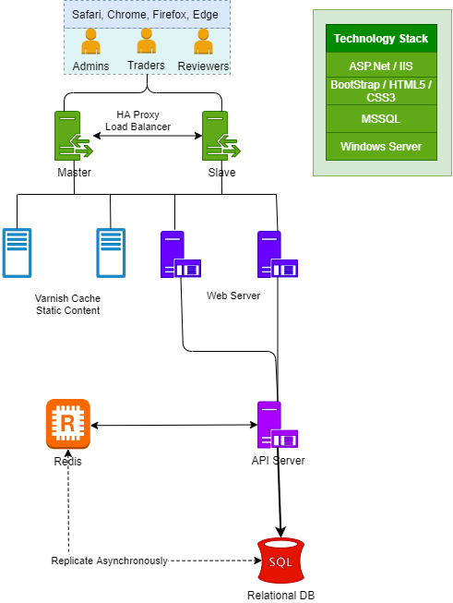

### Performance boost considerations

**Varnish and HA Proxy Layer**

**HAProxy**: Layer 7 traffic routing, first row of protection against DDOS (syn flood, slowloris, etc…), application request flow optimization

**Varnish:** Caching, compression. Could be used later as a WAF to protect the application

**Server:** hosts the application and the static content

**Traffic Flow**

Basically, the client will send all the requests to HAProxy, then HAProxy, based on URL or file extension will take a routing decision:

* If the request looks to be for a (pseudo) static object, then forward it to Varnish  
  If Varnish misses the object, it will use HAProxy to get the content from the server.
* Send all the other requests to the App Server. If configured properly, there should be only dynamic traffic here.

Varnish is not used as the default option in the flow, so as to avoid caching dynamic content as it could lead to somebody’s personal information sent to everybody…  
Furthermore, in case of massive misses or purposely built request to bypass the caches, it will prevent Varnish from hammering the App Servers as HAProxy protects them with a tight traffic regulation between Varnish and App Servers.

**Static Traffic flow**

* The client sends its request to HAProxy which sees that it is asking for a static content
* HAProxy forward the request to Varnish. If Varnish has the object in Cache (a HIT), it forwards it directly to HAProxy.
* If Varnish doesn’t have the object in cache or if the cache has expired, then Varnish forwards the request to HAProxy
* HAProxy randomly chooses a server. The response goes back to the client through Varnish.

In case of a MISS, HAProxy prevents Varnish to flood the servers. Furthermore, since Varnish sees only static content, its HIT rate is over 98%… So the overhead is very low and the protection is improved.

**Dynamic Traffic**

* The client sends its request to HAProxy
* HAProxy chooses a server based on cookie persistence or Load-Balancing Algorithm if there is no cookie.

The server processes the request and send the response back to HAPRoxy which forwards it to the client

## Hardware Architecture

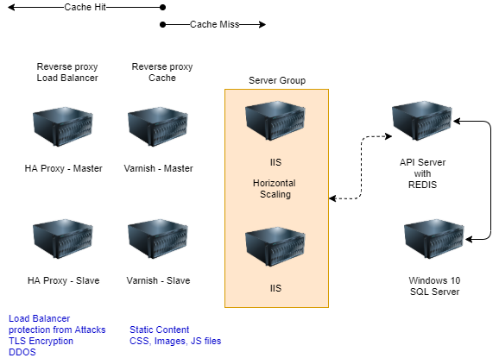

## Security Architecture

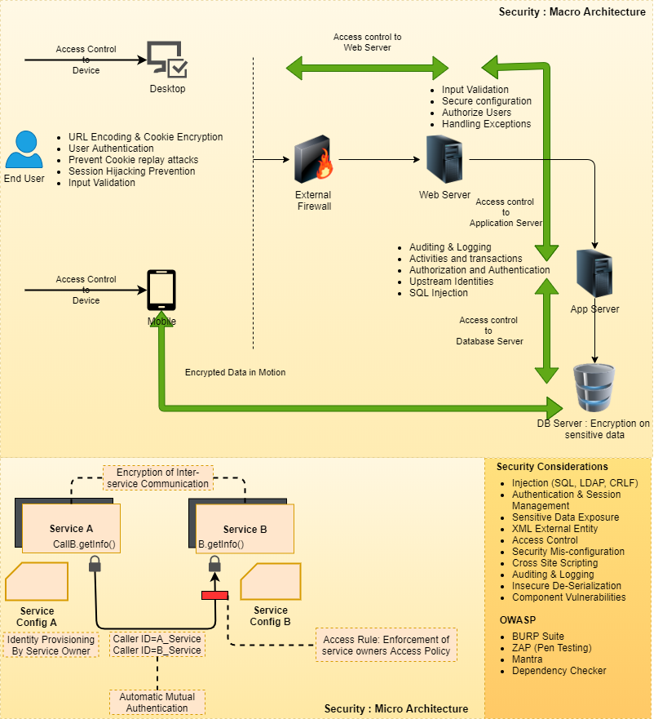

## Quality Assurance

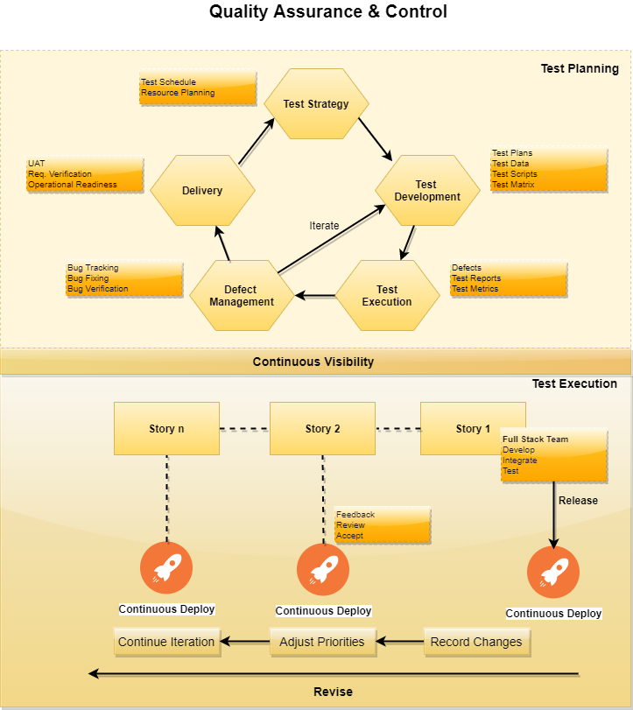

## Release and Deployment Process

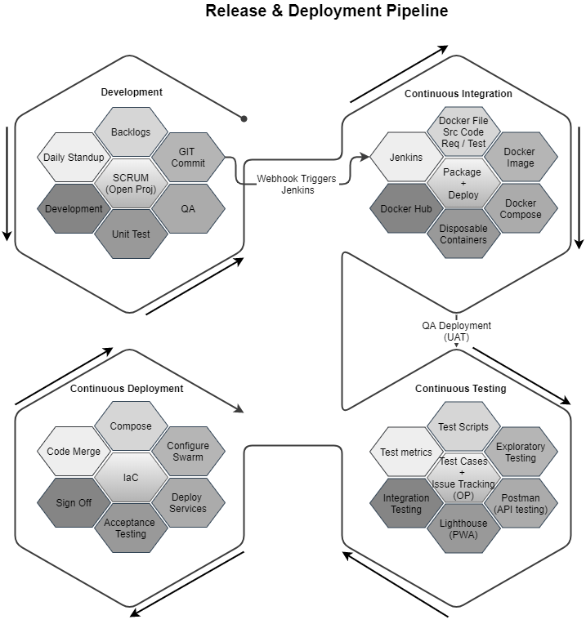

## Verbat’s Website Redesign and Enhancement Strategy

## NON-FUNCTIONAL REQUIREMENTS (OTHERS)

|  |  |
| --- | --- |
| **Requirements** | **Details** |
| User Experience and  UI Design | * The application will be developed in English and Arabic * The layout and graphical components will be created considering the usability factors |
| Performance | * Application will allow users to have smooth and quick access to the information or services they require. |
| Security | * Web security standards shall be followed. |
| Scalability | * Website shall be designed with the ability to add new services without impacting usability |
| Usability | * Website shall be user centric and its design shall be strongly influenced by user journeys. The designs and wireframes developed shall be technically executable |
| Accessibility compliance | * WCAG 2.0 compliance * TRA compliant * UN standards compliant |

## TECHNICAL CONFIGURATIONS

### DEVELOPMENT ENVIRONMENT

* ASP.net / C#
* MSSQL
* HTML 5 / CSS 3 / BootStrap
* IIS

### RECOMMENDED WED HOSTING PACKAGE - DEDICATED

* Operating System: Windows Server
* CPU: 4 cores
* Domains: Unlimited
* Disk Space: 500 GB
* Monthly Bandwidth: 50 GB
* IIS
* .Net SDK, ASP.net

### BROWSER

The application developed shall be compatible with the browsers listed below:

* Internet Explorer 11
* Mozilla Firefox 50 or above
* Chrome 50 or above

### TECHNICAL STANDARDS

* Testing Devices

Google Pixel     Android 7

Motorola Moto G Turbo Edition -   Android 6

* OS Version

Android: Android KitKat and above

IOS: IOS 9+

### TECHNICAL GUIDELINES

These guidelines provide instructions and conditions that will be adhered to during the development of the mobile application.

* API will be used, as the case may be, in realizing the features and functionalities mentioned.
* The client will finalize the functional requirements and UI/UX before the commencement of the project.
* Verbat will be testing the app in the mentioned devices only. Testing on devices other than the ones mentioned under the “Technical Standards “will have to be specified and provided by the client at the beginning of the development phase.
* The client will have to provide the details of the testing devices they are using before the start of development phase.
* Client should provide the relevant Developer's Account credentials before the development phase. In case Verbat needs to create the developer id, additional charges will be incurred by the client.
* The duration mentioned in the project timeline is for the development and testing; any delay or time taken by the review team to respond will not be Verbat’s responsibility.
* Any clarification required from client needs to be addressed within 02 business days.
* The apps will be developed / created within the guidelines of respective play store.
* Verbat will strictly follow the guidelines provided by the respective stores.
* Verbat will inform the client if any of the client requirements / request deviate from it.
* Customization of the features of the app will be susceptible to the limitation imposed by the respective platform/ store.
* Once development commences, the test device/screen sizes will not be susceptible to change. Any change requested by the client will have to go through change management.
* OS version support will be limited to the ones mentioned in the technical specifications. Further support will have to go through change management.

## PROJECT DELIVERY

### Agile Methodology

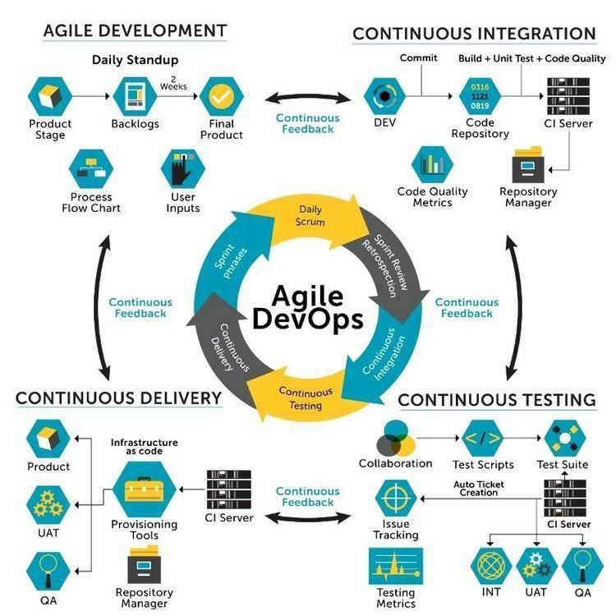

Verbat’s philosophy has been to deliver products that allowed clients to be intimately involved with the development activity. As early as 2005 Verbat had adopted the agile development practices into its pipeline for software development. This allowed clients to closely observe the product being developed. It created a tight feedback loop that allowed us, along with our clients to better understand the requirements and build a right sized and proportional product.

With the advent of next generation applications and tools that support a wide range of activities related to development, deployment and integration; the feedback loops became tighter and coupled, while at the same time it allowed us to create applications that were decoupled. Thus giving us the capability to have greater flexibility in development and deployment.

While development broke down the barrier between developers and management, Devops broke the barrier between software developers and operations teams. Our development and operations teams work under a single silo. While our Scrum teams are cross functional, in our quest to adopt better integration with operations, we have realized that Devops is not just a set of tools and processes, but a mindset and culture. We have fostered a culture collaboration and communication. Our scrum teams and Devops teams share a symbiotic relationship and they work united towards a common goal.

As a company, we have adopted the following tenets in our Devops philosophy

**Speed:** i.e. Move at a high velocity so as to innovate faster for customers and adapt to changing markets better, and grow more efficient at driving business results.

**Rapid Delivery:** Increase the frequency and pace of releases so we can innovate and improve products faster and thus respond to customers’ needs and build competitive advantage.

**Reliability:** Ensure the quality of application updates and infrastructure changes so we can reliably deliver at a more rapid pace while maintaining a positive experience for end users.

**Scale:** Operate and manage infrastructure and development processes at scale.

**Improved Collaboration:** Build more effective teams under a DevOps cultural model, which emphasizes values such as ownership and accountability. Developers and operations teams collaborate closely, share many responsibilities, and combine their workflows.

**Security:** Move quickly while retaining control and preserving compliance. We adopt a DevOps model without sacrificing security by using automated compliance policies, fine-grained controls, and configuration management techniques.

Please see below an illustration of our technology stack. The tools of the trade that allow us to practice an Agile and Devops centric framework

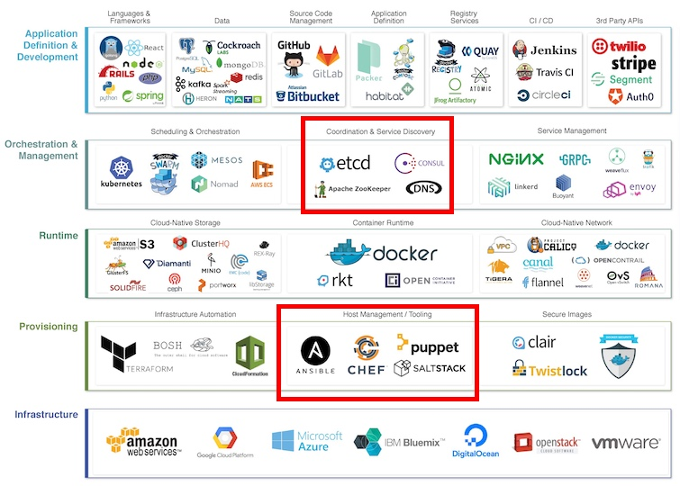

### PROJECT MANAGEMENT

The Verbat development center strictly follows industry standards on quality. Our project management process is governed by the Verbat Quality Management system and is verified through internal audit programs.

Verbat will dedicate a project leader for the proposed implementation. Furthermore, Verbat proposes the client to identify one project manager (*CSPM – Client-Side Project Manager)* who will be driving all activities undertaken by the client, and will be the single point of contact for Verbat.

### ROLES & RESPONSIBILITIES

Verbat will assign its own dedicated Project Lead (*VPL – Verbat Project Lead*) for the client. The VPL will be responsible for planning and management of all activities related to the project. Furthermore, the VPL will work closely with CSPM, on all periodic status updates and will ensure high level visibility and comfort on the progress of the project.

### DELIVERY ACTIVITY SUMMARY

|  |  |
| --- | --- |
| Activities | Description |
| Proof of Concept | Working Model of the project with two languages. |
| Detailed Requirement Analysis | Verbat team to conduct detailed study of requirement for the phase. If clarification is required, the team will reach out to Client for more information and/or time for discussions. |
| DB Design | DB design for central and test DB. |
| Software Requirement Specification document (SRS), | Once the requirement analysis is completed, Verbat team will submit the SRS document for approval |
| UI/UX Design, Prototyping | Based on the SRS, Verbat UX/UI team will work on the UI/UX of the screens and submit prototype for approval |
| Functional Specification Document (FS) With solution architecture | Once the UI/UX is approved, Verbat shall submit an FS document for approval. |
| Development | Actual system development starts based on the FS. This involves detailed design and software development of Web Application. |
| Testing | Test Planning, test plan creations, internal, integration testing and user acceptance testing. |
| Deployment | Deploying the latest build in the Verbat Test Server |

### PROJECT IMPLEMENTATION PLAN

Verbat will be providing the solution in a stand-alone fixed bid approach which ensures minimum viable solution for quick wins with core focus on the long-term business objective and outcome. Once the implementation is over, Verbat will initiate the application maintenance process (*once the maintenance contract is signed*) which continues to extend after the implementation.

### DELIVERABLES

* Proof of Concept
* Project schedule
* Requirement Traceability Matrix
* Communication management plan
* Software Requirement Specification Document (SRS)
* Prototype Design
* Functional Specification Document (FS) with final architecture
* Fully Developed & Tested Application
* Latest source Code
* Technical documentation
* User manuals

### ESTIMATED DELIVERY TIME

The timeline estimated for delivering the application will be as below:

* Working days to complete the proof of concept on completion of resource mobilization.
* Working days to complete the SRS & prototype of Language Translation Application.
* Working days to complete the development.

| **Activity** |
| --- |
| Contract Signoff (T0) |
| Proof of Concept-Allocate Resource |
| Proof of Concept-Complete |
| Proof of Concept- Approval (T1) |
| Detailed Requirement Gathering |
| Software Requirement Specification Document (SRS) |
| SRS Approval (T2) |
| System UI/UX Prototype-Complete |
| System UI/UX Prototype-Approval (T3) |
| Functional Specification (FS) |
| FS Approval (T4) |
| Development Phase-Complete |
| Perform QC (Unit Testing and Integration Testing) |
| System ready for UAT |
| UAT Acceptance on Verbat production server (T5) |

*Note:*

* *The above-mentioned timeline is in Working Days.*
* *Upon project confirmation, Verbat requires a lead time of minimum () working days for resource mobilization for proof of concept.*
* *Resource mobilization will be initiated post the confirmation of the project along with LPO, signed*

*proposal and advance payment.*

* *The initiation of the UI/UX/Prototype development is dependent on the confirmation of SRS.*
* *The above-mentioned timeline for development is post-confirmation of FS.*
* *Documentation submitted after project initiation and system study supersedes any proposal or documentation submitted during initial requirement gathering / discussion / negotiation.*
* *Project plan will be submitted post the confirmation of project with necessary payments.*
* *Any delay in getting the approvals of deliverables from client will cause change in timelines and the revised timelines will be updated in weekly status reports shared with client after the project commencement.*
* *All approvals and queries regarding the client requirement and any queries which may hinder the project advancement at any stage should be answered by the client within () business days from the time of initiation, failing which, the time delay will get added to the actual effort and timeline estimated.*

### DEPLOYMENT DETAILS

* Cloud server for hosting the application will be the responsibility of the client.
* Verbat will deploy the application on client’s cloud server after the client conducts the necessary acceptance testing.

*Note:*

* *Hosting the application at Verbat’s production server (hosting charges) will call in for additional charges. In the event, client wants to procure SSL, the same can be provided by Verbat at additional cost.*
* *Only deployment of the application will be the responsibility of Verbat, any additional installation will be charged separately.*

### RELEASE PLANNING

* Client will be informed about the release date and time through email.
* Client performs the UAT

### RISK CONTINGENCY PLANNING

Verbat has identified various risk factors associated with this assignment and understands the impact of these risk factors on the project schedules. The objective of this section is to highlight for both Verbat and client, the risk factors, to analyze the impact of the risks on project execution, and to propose strategies to control and reduce the impact of the risk factors. These various risks, which could arise during the project, are tabulated below along with mitigation implementation.

| **Type of risk** | **IMPACT** | Risk Mitigation | Risk Handling |
| --- | --- | --- | --- |
| Scope Creep | **H** | Functions and features will be detailed in system requirement document and will go through client approval. Once this document is approved, all changes will go through the change management process for impact assessment. | Proper change management procedure will be implemented |
| Delay in client feedback | **H** | The plan is prepared with sufficient lead-time for reviews and approvals.  The client will advise us on all dates connected to the document review and approval. | The request for feedback will be escalated if not attended to at the right time so that the schedules are not affected. Deemed acceptance criterion is finalized up-front and will be followed |
| Non-availability of necessary software, frameworks, database instances and infrastructure at client’s hosting environment (If hosting support is provided by Verbat) | **M** | Client will be informed in advance on these requirements. | Possible impact to schedule |
| Manpower attrition | **L** | All efforts will be made to ensure that all initiatives are process dependent. To mitigate risk Verbat/Client will train a person to ensure all back-ups are in place. | A new person will be appointed as early as possible, provided the required project-specific training and mentoring is in place - to minimise impact of attrition on the project |

*H-High, M-Medium, L-Low, NA-Not Applicable*

## PROJECT ASSUMPTIONS

The project solution and technology are created from the initial understanding of the requirement shared with Verbat through mails and meetings. The proposed solution is based on the following assumptions:

### OBJECTIVES

* The requirement is to develop 2 web sites for the client. The project involves development of such sites with a focus on usability and accessibility. The ultimate aim of the site is to maximize user experience.

### DESIGN

* Client to provide Verbat with the branding guidelines.
* Color theme shall be provided by the client.
* Client shall provide licensed images and logos in specified size & format.
* Client shall provide the text and associated images for the proposed application. Text should be provided in digital format preferably in MS Word 2013 or above
* Verbat is free to use custom-made template for design, if required.

### DEVELOPMENT

1

Client shall procure the following services - Google Translation Services. (If required)

* Additional charges may be incurred for archiving and encryption services (depending on the requirements).
* Peers making use of translation services are likely to experience a latency which is directly proportional to the bandwidth of their network connection.
* The application requires a fast internet connection for real time communication.
* Effort for maintenance and support activity has not been included in this proposal. It will be considered separately on the basis of Time and Material Billing or an AMC
* The effort for System integration activities are assumed to take no longer than 3 days per integration. Anything more shall be considered as additional effort.
* Award creation, nomination & voting pages are assumed to have a pre-defined and standardized template.
* Web site shall be responsive for desktops, laptops and tablets. It may not be 100% responsive with mobile phones.

# **OUT OF SCOPE**

With the ever-evolving digital market, the requirement should be clear to both the parties involved, hence the importance of mentioning the out of scope details of the project. Following are considered to be out of scope while creating this proposal:

* Purchase of images, fonts
* Any language other than English
* Migration of existing data / Database migration
* Content writing / proof reading / Data Replication / Manual data entry
* Content or image procurement or uploading or editing
* Native iOS App Development / Android App development
* Developer account creation and Maintenance (*IOS and Android Store*)
* Adding new features to the application other than mentioned in the functional specifications. Such requests will be handled via change management. For Change management details, please refer to section titled “Change Management” in the Proposal. (*refer page no: 33*)
* Annual Maintenance Contract (*Bug fixing, debugging, enhancements*) – Please refer to section titled “Maintenance and Support”, unless contracted for. (*refer page no: 34*)
* Hosting Infrastructure and Maintenance (*web and email hosting*), unless contracted for.
* Backup solution and Disaster recovery unless contracted for.
* Physical deployment on-site / installation of the application in devices and physical connection, installation of system.
* Integration with third-party, if any, other than mentioned in the functional specifications
* Hardware Integrations / procurement and purchase
* Procurement of SMS gateway / payment gateway / email gateway
* Integration of SMS gateway / payment gateway
* SSL Purchase and installation, if any
* Plugin/template purchases, if any
* API purchases
* OS other than mentioned in the Hardware Interface
* Relevant / related software libraries
* Mobile offline access or operations
* Verbat shall develop no more than 3 e-services. Additional e-services are out of scope until agreed upon otherwise.
* It is assumed that these services are part of the main domain.
* Verbat does not own a Usability lab and hence shall not be providing such services
* Verbat shall not be responsible for the management of the eservices sub domain. Any development related to it is out of scope
* The client shall be responsible for delivering the Arabic content on time. Client is expected to notify Verbat on time with regards to corrections related to grammar or typos.
* The web site shall not be tested for IE 11 or its predecessors.
* Browsers covered for testing are Chrome, Edge, Firefox and Opera

# **CHANGE MANAGEMENT**

Any addition which comes out of the project scope, upon and after the launch of the website will be considered as change management. Verbat recommends the following change management procedures for the same:

* Changes will be implemented only after raising a change request.
* Change requests will be studied and an impact analysis will be performed on the existing work flow.
* Upon assessment of the impact, effort estimation will be calculated and raised as an additional requirement.
* The change request will be initiated only after receiving a formal approval from the client for the additional changes raised.
* Changes which are out of scope will be charged @ per man day rate.

Activities for change scheduled

Modules checked in

Unit testing done

Change request accepted

Informed of the Action

Implementation of changes

Modules checked out

Activities planned and scheduled

Effected modules identified

New system released with change request

Changes made & documented

System

Need for change recognized

User submits change request

Evaluate for cost, schedule & effort

Change control authority

yes

No

## MAINTENANCE & SUPPORT

* Maintenance contracts by default are supported as per the basic SLA terms.
* AMC with Basic SLA is charged at % of the total project value. Additional Effort/change management request will be added towards Total Value of the Project to determine the AMC value.
* Maintenance support is limited to providing application support for ensuring the consistency of the look-and-feel, bug fixes and user issues i.e. maintenance and support of the existing features of the application.
* Support does not in any way cover providing technical or other support to the end users or hardware support. The maintenance agreement does not include functionality changes or feature additions which are handled as change requests which will be charged per man day rate. AMC does not include server support, maintenance and application deployment.
* AMC charges will cover Off-Site Support and Debugging. Support includes E-mail, telephone and video conference (if required). In the event, the application is hosted with the client or if it is a client server development; necessary remote desktop connectivity should be provided for carrying out maintenance activities.
* All maintenance support will be executed by Verbat off-site team. In the event of any need for on-site work, all expenses incurred for such trips (flights, accommodation, meals transportation) will be payable to Verbat by client.
* Gap in AMC - In case if the client does not opt an AMC for a year and wants to renew it after that period, % of the AMC amount for the year for which AMC is not taken will also be payable if the client wishes to renew the AMC contract.

|  |  |  |  |  |
| --- | --- | --- | --- | --- |
| **SLA Type** | **Max Response Time** | | **Max Resolution Time** | **Target** |
| Basic | 1 working day | 3 working days | | Request / incident / problem tickets |

*Note:*

* *Time zone applicable as per India Time Zones (3:30 GMT to 12:30 GMT, Monday to Friday)*
* *Please note that the AMC support shall start only after all the necessary sign-offs (AMC Document) to this effect have been given.*
* *It is not mandatory that the client should opt for an AMC. The client will still be supported on an ad-hoc basis on an agreed man-day rate.*
* *AMC Payment Terms: 100% to be paid as advance.*

AMC Option: Client can opt for time and material based Annual Maintenance, the details of which will be shared post the completion of project.

# **TERMS AND CONDITIONS**

## ACCEPTANCE CRITERIA

* UAT (User Acceptance Test) sign off should take place within Days from the first release of the application and the acceptance confirmation needs to be mailed to Verbat failing which Verbat will consider the project as approved by the client.
* Any comments and reasons for rejection need to be documented and the same needs to be sent as an email from the official e-mail id of client to Verbat on or before days from the first release.
* Timeframe for acceptance for any further release will be mutually agreed and finalized between client and Verbat depending on the UAT Comments

## WARRANTY

* Verbat shall provide a bug ﬁx warranty at no additional cost for 30 days from the date of acceptance of the project, for correction of any errors in the developed application that may be attributed to Verbat.
* However, this does not cover modifications by Client, or use of the application on an environment other than the proposed environment, or other circumstances outside Verbat’s reasonable control. In such cases Verbat reserves the right to charge for its services.
* All error corrections will be executed by Verbat offsite team. In the event of any need for on-site work, all expenses incurred for such trips (flights, accommodation, meals, transportation) will be payable to Verbat by Client.

## SOURCE CODE & INTELLECTUAL PROPERTY RIGHTS

* Upon completion of the Project and 100% completion of the payment, the client will have access to the source code except for proprietary codes, developer tools and third-party applications etc.
* The solution offered will be the intellectual property of the client and will be made available to the client on an “unlimited license” basis.
* No person or organization, other than Verbat or any person authorized by Verbat in writing, has permission to modify/change the software solution to be eligible to get continued support from Verbat as per the support terms defined under this document.
* Verbat accepts no liability or damages of any kind arising out of use or non-use of the software delivered. The responsibility of testing of software lies with the client.

## GENERAL TERMS AND CONDITIONS

* Offer Valid for 30 calendar days from the date of submission of the Proposal.
* An average of 20 working days are assumed in a month.
* All the development activities will be carried out from our off-shore development center in India.
* All the documentations will be provided in English.
* Third party components may be used to develop this application.
* The scope of the project is to develop the application as detailed in the scope of the project and mentioned in this proposal. Any changes or additions will have to go through our change management process.
* This proposal is derived and concluded from either the RFQ /RFP/data shared via email / information transferred during an initial requirement analysis meeting / tele-conversation. Verbat reserves the right to change the terms of this proposal if the final terms (including the costing), features & functionalities and timelines are changed during the course of the project. Hence any fees quoted / timeline committed in this proposal may not be considered as final unless agreed upon and signed by both parties.
* Web Application will be best viewed only in the environment mentioned in the section Browser Compatibility.
* All source codes and other project artifacts will adhere to the Verbat document templates and internal coding standards.
* The documents delivered to the client include the ones mentioned under ‘Deliverables’ and these will adhere to Verbat’s internal document standards.
* Acceptance criteria shall be based on the clauses which were mutually discussed between Verbat and client at the Requirement Analysis phase. The same will be documented and approved by both parties through official emails.
* In the event that the Client requires any extension of the proposed acceptance schedule, the associated effort and cost of such extension will be mutually reviewed.
* If the project needs to be put on Hold / Stopped, a minimum notice period of 1 week is required along with the duration of the holding period. Thereafter Verbat will make a final decision based on the request.
* If deployment is done in the client’s server, Verbat will not be held responsible for any performance issues arising due to hardware malfunctions.
* The Client is responsible for all data-backups in case the application is not hosted on the Verbat server.
* All source codes will only be delivered or uploaded on the production server after the due payments are made to Verbat.

## GENERAL ADMINISTRATIVE, TECHNICAL & FUNCTIONAL ASSUMPTIONS

* Detailed system study is required before the start of the project.
* During the requirement gathering phase, authorized personnel from the Client’s side are expected to be available for discussions and finalization of the HLD (High Level Design), before the development commences.
* Type of reports, formats if under the scope of the project, need to be specified by the Client before the project sign off.
* Workflows if under the scope of the project, need to be specified/ confirmed by client before project signoff.
* Verbat assumes that all sign-offs from the Client will be provided within the agreed and specified timeframe.
* Client will provide all the necessary contents, both text and imagery, before starting the project in the format suggested by Verbat (if any).
* The client should provide the relevant information and data, well in advance of the execution of the related activity. Non- availability of this information or data may lead to an interruption of work, which may result in a delay in delivery as well as additional costs to the client.
* The Client should possess a server with the technical specifications recommended by Verbat for the proposed application.
* The Client will be provided with a one-time training (train the trainer) on how to use the application via a video conference (maximum of 4 hours). Additional training requests will be charged at cost to the client.
* Cost of all third-party components to be borne by the client.
* Application will support in three languages which are supported by Google Text to Speech API.

# **FINANCIALS**

## Curriculum Management Application

|  |  |  |
| --- | --- | --- |
| Sl. | Description | Amount (USD) |
| 01. |  | XXXX USD |

*Note:*

* *The above cost is exclusive of VAT applicable in UAE*
* *The above cost includes the cost of third-party service of non-translated calls.*
* *The above cost does not include third-party API purchases.*
* *The above estimate is based on the initial understanding of the requirement grounded on the details shared by client via meetings and tele-conversations. If Verbat finds during the requirement gathering phase that the actual requirements uncovered are different form the original, this might affect the estimates provided and Verbat shall exercise rights to renege on the contract. Clarifications/Changes in the scope during system study/ analysis may call in for additional effort and timeline.*
* *For feature additions, please refer section titled “Change Management “.*
* *LPO to be raised in the name of “Verbanet Technologies LLC” for project initiation*

## PAYMENT TERMS

* % of the proof of concept as advance.
* % of proof of concept on delivery of POC
* % of Language Translation Application as advance.
* % of Language Translation Application on completion of:
* SRS
* Prototype
* % of Language Translation Application to be paid on UAT Signoff.

*Note:*

* *Payment should be made within 7 days from the date of invoice.*

### MODE OF PAYMENT

Wire transfer to our bank account

|  |  |  |
| --- | --- | --- |
| Particulars | **Option 01** | **Option 02** |
| Bank Name | Commercial Bank of Dubai | Emirates NBD |
| Account Name | Verbanet Technologies LLC | Verbanet Technologies LLC |
| Account Number | 1000305555 | 1011492858201 |
| Swift Code | CBDUAEAD | EBILAEAD |
| IBAN Number | AE840230000001000305555 | AE61 0260 0010 1149 2858 201 |
| Bank Address | Al Qusais Branch, P.O Box 2668, Al Qusais | Mamzar Branch, Dubai |

*Note:*

* *Bank charges incurred during wire transfer to be borne by the client.*
* *Any local taxes / VAT applicable to be borne by the client.*
* *Client invoices will include VAT charges in addition to the application cost.*



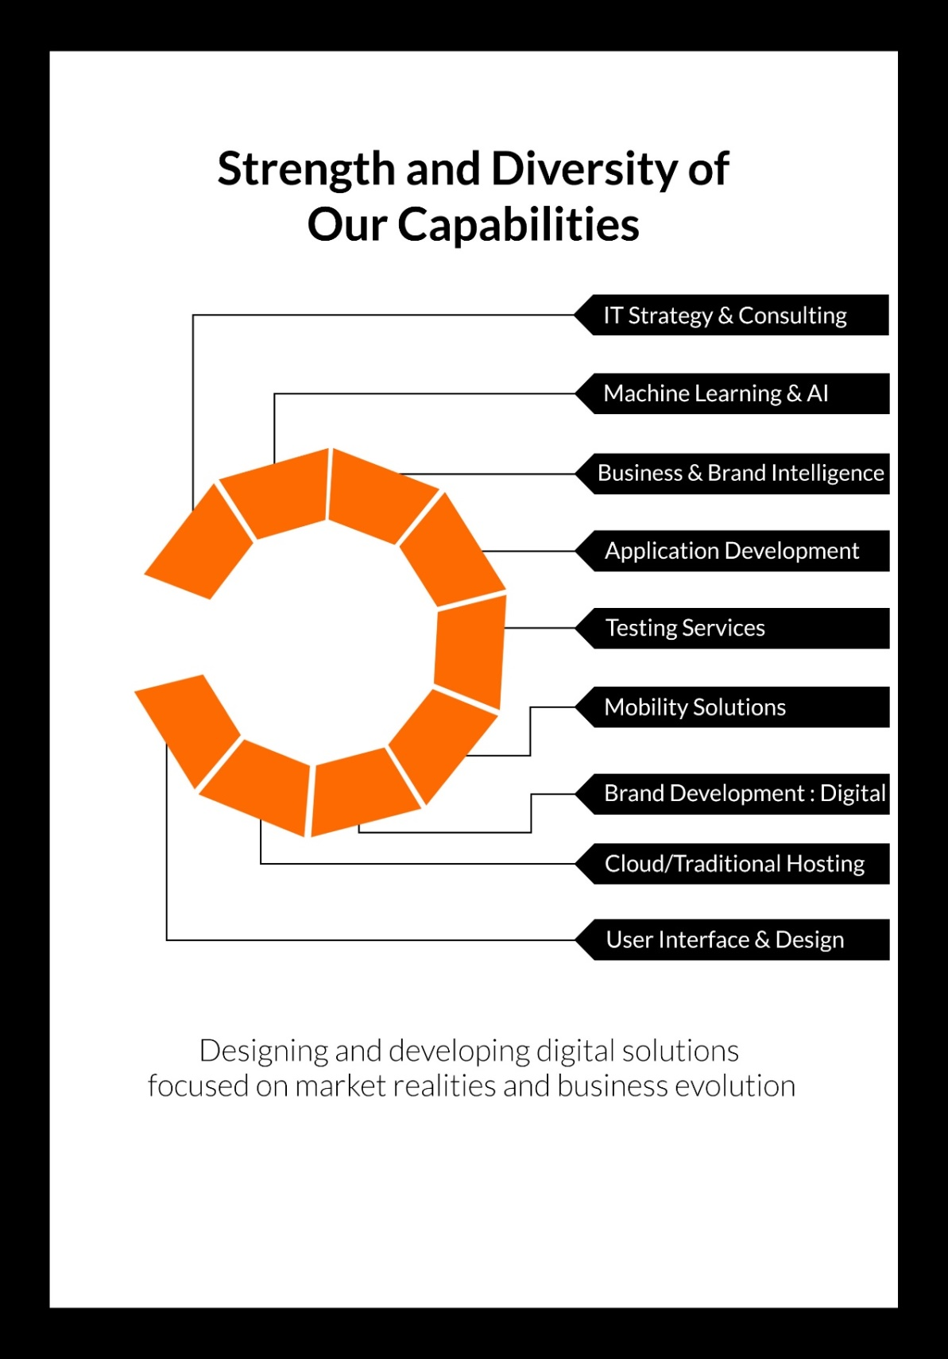

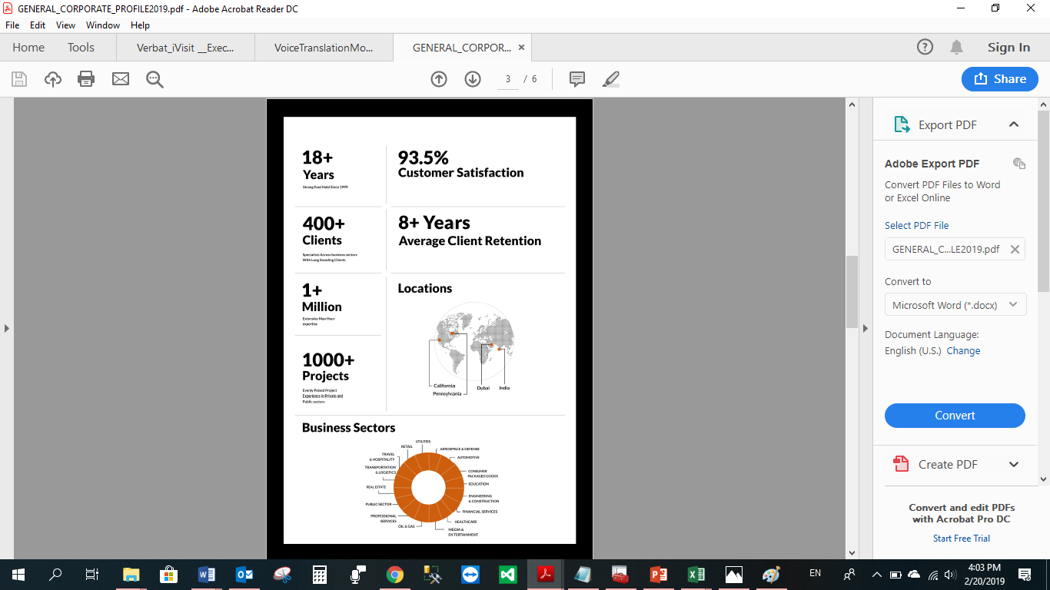

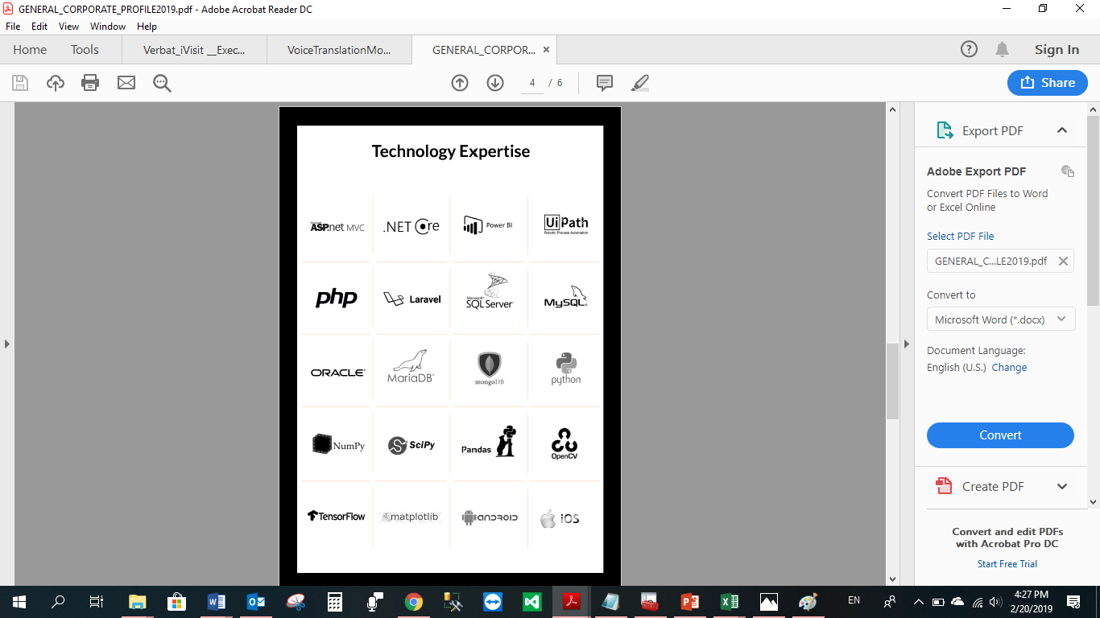

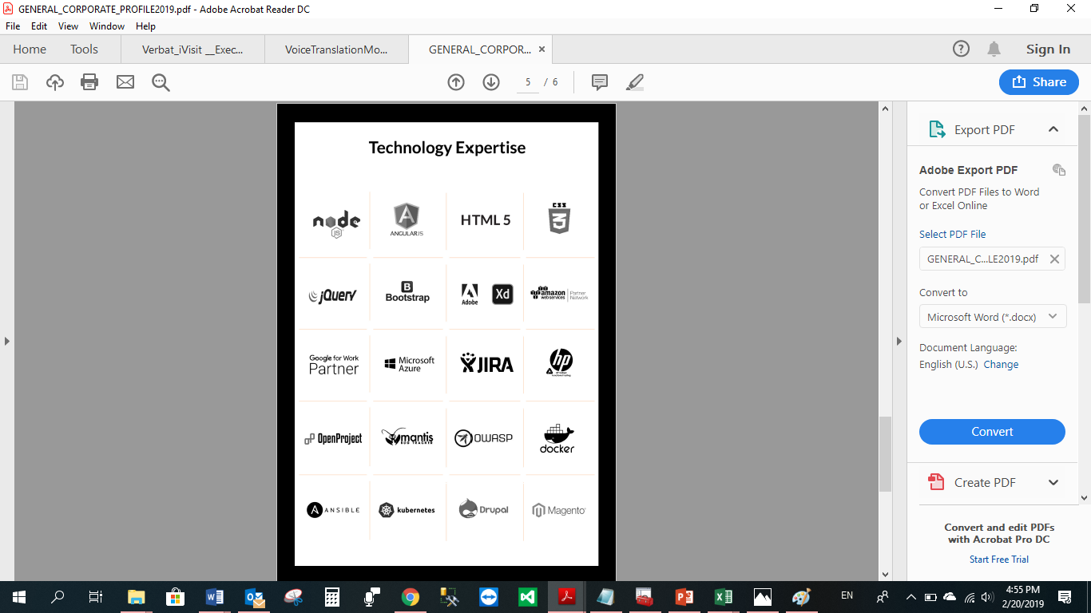

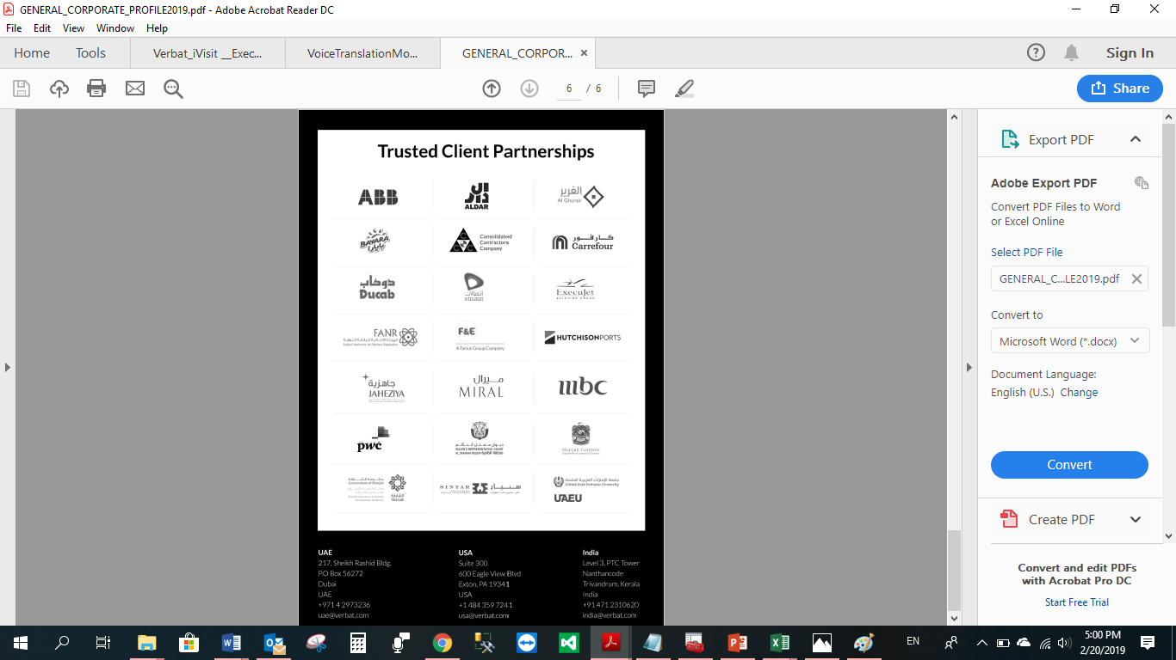

**WITH OUR**

**SINCERE THANKS.**

CONFIDENTIALITY NOTICE:

This Proposal is conﬁdential and contains proprietary information and intellectual property of Verbanet Technologies LLC. Neither this proposal nor any of the information contained herein may be reproduced or disclosed under any circumstances without the express written permission of Verbanet Technologies L.L.C (hereby known under its brand name of Verbat in the United Arab Emirates). 2019. All Rights Reserved.